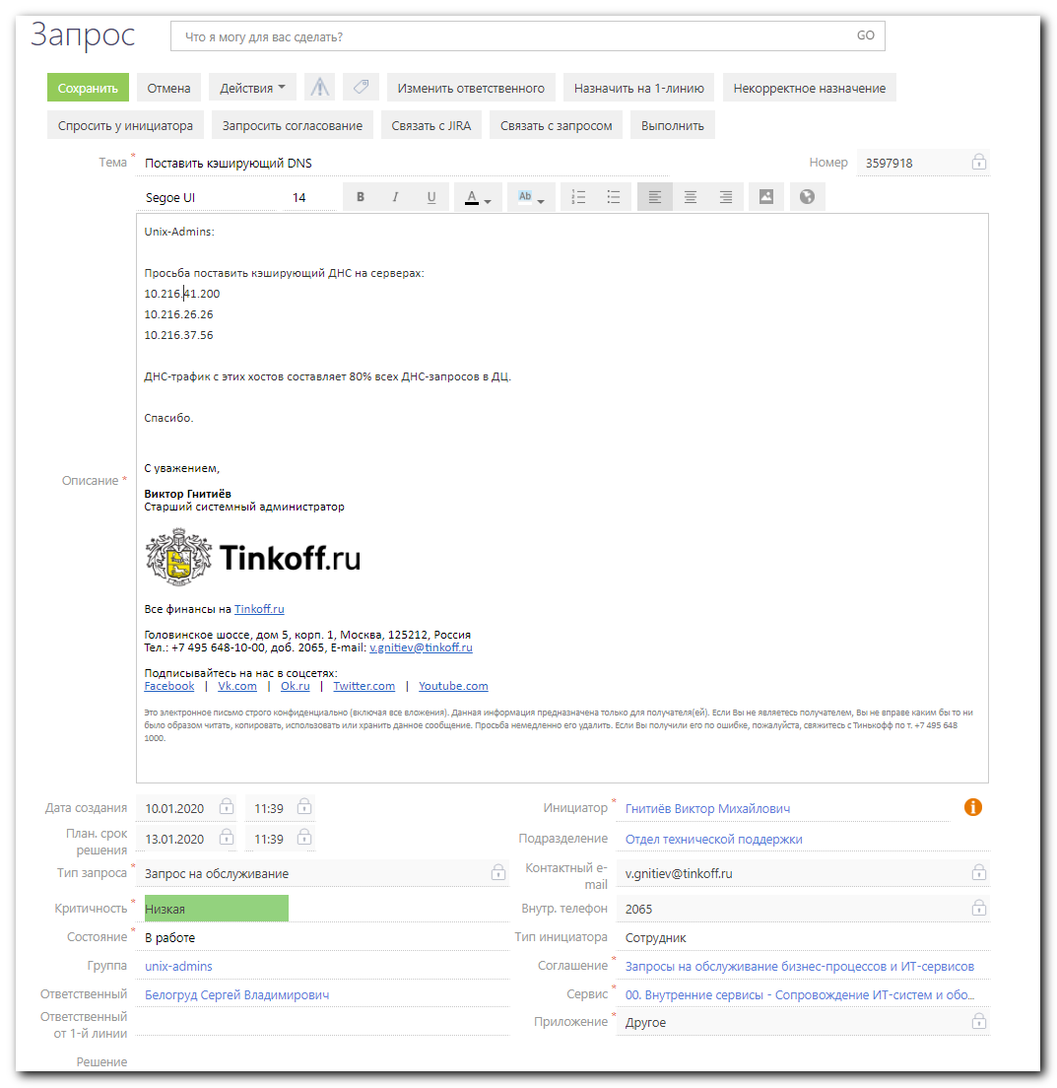

root@m1-itpm-01p:~# cat /etc/os-release
PRETTY_NAME="Debian GNU/Linux 9 (stretch)"
NAME="Debian GNU/Linux"
VERSION_ID="9"
VERSION="9 (stretch)"
ID=debian
HOME_URL="https://www.debian.org/"
SUPPORT_URL="https://www.debian.org/support"
BUG_REPORT_URL="https://bugs.debian.org/"
root@m1-itpm-01p:~#

root@m1-itpm-01p:~# cat /etc/resolv.conf
nameserver 127.0.0.1
nameserver 10.219.50.4
nameserver 10.219.50.5
search tcsbank.ru
root@m1-itpm-01p:~#

root@m1-itpm-01p:~# netstat -nlptu | grep 53
tcp 0 0 127.0.0.1:953 0.0.0.0:* LISTEN 20631/named
tcp 0 0 127.0.0.1:53 0.0.0.0:* LISTEN 20631/named
udp 0 0 127.0.0.1:53 0.0.0.0:* 20631/named
root@m1-itpm-01p:~#

root@m1-itpm-01p:~# cat /etc/bind/named.conf.options
options {
directory "/var/cache/bind";

// If there is a firewall between you and nameservers you want
// to talk to, you may need to fix the firewall to allow multiple
// ports to talk. See http://www.kb.cert.org/vuls/id/800113

// If your ISP provided one or more IP addresses for stable
// nameservers, you probably want to use them as forwarders.
// Uncomment the following block, and insert the addresses replacing
// the all-0's placeholder.

// forwarders {
// 0.0.0.0;
// };

//========================================================================
// If BIND logs error messages about the root key being expired,
// you will need to update your keys. See https://www.isc.org/bind-keys
//========================================================================
//dnssec-validation auto;
dnssec-validation no;

auth-nxdomain no; # conform to RFC1035

listen-on port 53 { 127.0.0.1; };
listen-on-v6 port 53 { none; };

allow-query { any; };
allow-transfer { "none"; };
recursion yes;
allow-recursion { any; };

allow-query-cache { any; };
forwarders { 10.219.50.4; 10.219.50.5; };
forward first;

};
root@m1-itpm-01p:~#

root@m1-itpm-01p:~# dig @127.0.0.1 repo-linux.tcsbank.ru.

; <<>> DiG 9.10.3-P4-Debian <<>> @127.0.0.1 repo-linux.tcsbank.ru.
; (1 server found)
;; global options: +cmd
;; Got answer:
;; ->>HEADER<<- opcode: QUERY, status: NOERROR, id: 24938
;; flags: qr rd ra; QUERY: 1, ANSWER: 2, AUTHORITY: 13, ADDITIONAL: 1

;; OPT PSEUDOSECTION:
; EDNS: version: 0, flags:; udp: 4096
;; QUESTION SECTION:
;repo-linux.tcsbank.ru. IN A

;; ANSWER SECTION:
repo-linux.tcsbank.ru. 740 IN CNAME ds-repo01.tcsbank.ru.
ds-repo01.tcsbank.ru. 505 IN A 10.216.42.6

;; AUTHORITY SECTION:
. 73165 IN NS f.root-servers.net.
. 73165 IN NS d.root-servers.net.
. 73165 IN NS b.root-servers.net.
. 73165 IN NS j.root-servers.net.
. 73165 IN NS m.root-servers.net.
. 73165 IN NS a.root-servers.net.
. 73165 IN NS l.root-servers.net.
. 73165 IN NS h.root-servers.net.
. 73165 IN NS i.root-servers.net.
. 73165 IN NS g.root-servers.net.
. 73165 IN NS e.root-servers.net.
. 73165 IN NS c.root-servers.net.
. 73165 IN NS k.root-servers.net.

;; Query time: 1 msec
;; SERVER: 127.0.0.1#53(127.0.0.1)
;; WHEN: Mon Jan 13 17:36:41 MSK 2020
;; MSG SIZE rcvd: 301

root@m1-itpm-01p:~#

root@m1-itpm-01p:~# ls /etc/bind/named.conf*
/etc/bind/named.conf /etc/bind/named.conf.default-zones /etc/bind/named.conf.local /etc/bind/named.conf.options
root@m1-itpm-01p:~#

root@m1-itpm-01p:~# cat /etc/bind/named.conf
// This is the primary configuration file for the BIND DNS server named.
//
// Please read /usr/share/doc/bind9/README.Debian.gz for information on the
// structure of BIND configuration files in Debian, *BEFORE* you customize
// this configuration file.
//
// If you are just adding zones, please do that in /etc/bind/named.conf.local

include "/etc/bind/named.conf.options";
include "/etc/bind/named.conf.local";
include "/etc/bind/named.conf.default-zones";
root@m1-itpm-01p:~#

root@m1-itpm-01p:~# cat /etc/bind/named.conf.local
//
// Do any local configuration here
//

// Consider adding the 1918 zones here, if they are not used in your
// organization
//include "/etc/bind/zones.rfc1918";

root@m1-itpm-01p:~#

root@m1-itpm-01p:~# cat /etc/bind/named.conf.default-zones
// prime the server with knowledge of the root servers
zone "." {
type hint;
file "/etc/bind/db.root";
};

// be authoritative for the localhost forward and reverse zones, and for
// broadcast zones as per RFC 1912

zone "localhost" {
type master;
file "/etc/bind/db.local";
};

zone "127.in-addr.arpa" {
type master;
file "/etc/bind/db.127";
};

zone "0.in-addr.arpa" {
type master;
file "/etc/bind/db.0";
};

zone "255.in-addr.arpa" {
type master;
file "/etc/bind/db.255";
};

root@m1-itpm-01p:~#

#
# I’ve found, why bind 9 doesn’t resolve reverse addresses in network 10.x.x.x 172.x.x.x and so on.
#

# Option “empty-zones-enable no;” is significant.
# Without it the bind automatically generate local zones and they are empty.
# In this case local revers zones stop resolving.
# Bitch, fuckig bitch!
#
# https://kb.isc.org/docs/aa-00800
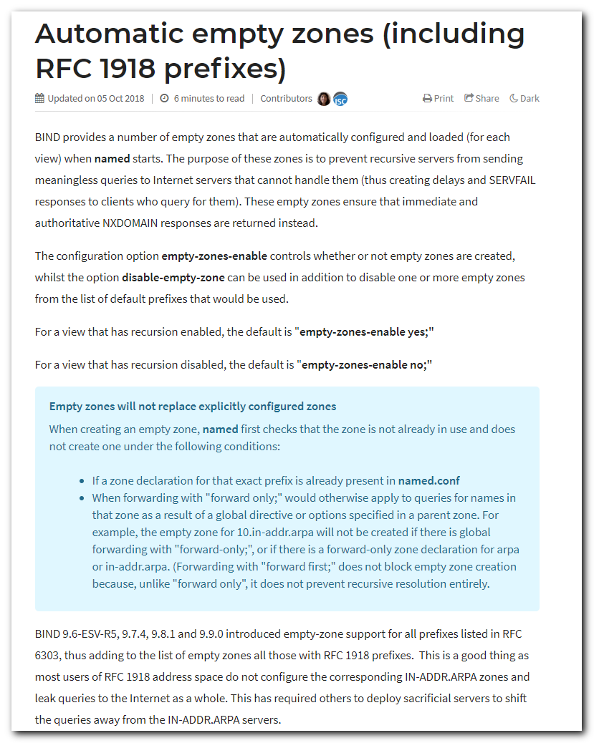

#
# If I comment this line in named.conf.options.
#
// empty-zones-enable no;

#
# Look, what this bitch doing…
# Burn to hell fucking bitch!
#
root@m1-itpm-01p:/etc/bind# vim named.conf.options
root@m1-itpm-01p:/etc/bind# systemctl start bind9

Jan 23 12:37:26 m1-itpm-01p systemd[1]: Started BIND Domain Name Server.
-- Subject: Unit bind9.service has finished start-up
-- Defined-By: systemd
-- Support: https://www.debian.org/support
--
-- Unit bind9.service has finished starting up.
--
-- The start-up result is done.
Jan 23 12:37:26 m1-itpm-01p named[21180]: starting BIND 9.10.3-P4-Debian <id:ebd72b3> -f -u bind -4
Jan 23 12:37:26 m1-itpm-01p named[21180]: built with '--prefix=/usr' '--mandir=/usr/share/man' '--libdir=/usr/lib/x86_64-linux-gnu' '--infodir=/usr/share/info' '--sysconfdir=/etc/bind' '--with-python=python3
Jan 23 12:37:26 m1-itpm-01p named[21180]: ----------------------------------------------------
Jan 23 12:37:26 m1-itpm-01p named[21180]: BIND 9 is maintained by Internet Systems Consortium,
Jan 23 12:37:26 m1-itpm-01p named[21180]: Inc. (ISC), a non-profit 501(c)(3) public-benefit
Jan 23 12:37:26 m1-itpm-01p named[21180]: corporation. Support and training for BIND 9 are
Jan 23 12:37:26 m1-itpm-01p named[21180]: available at https://www.isc.org/support
Jan 23 12:37:26 m1-itpm-01p named[21180]: ----------------------------------------------------
Jan 23 12:37:26 m1-itpm-01p named[21180]: adjusted limit on open files from 4096 to 1048576
Jan 23 12:37:26 m1-itpm-01p named[21180]: found 24 CPUs, using 24 worker threads
Jan 23 12:37:26 m1-itpm-01p named[21180]: using 12 UDP listeners per interface
Jan 23 12:37:26 m1-itpm-01p named[21180]: using up to 4096 sockets
Jan 23 12:37:26 m1-itpm-01p named[21180]: loading configuration from '/etc/bind/named.conf'
Jan 23 12:37:26 m1-itpm-01p named[21180]: reading built-in trusted keys from file '/etc/bind/bind.keys'
Jan 23 12:37:26 m1-itpm-01p named[21180]: GeoIP Country (IPv4) (type 1) DB not available
Jan 23 12:37:26 m1-itpm-01p named[21180]: GeoIP Country (IPv6) (type 12) DB not available
Jan 23 12:37:26 m1-itpm-01p named[21180]: GeoIP City (IPv4) (type 2) DB not available
Jan 23 12:37:26 m1-itpm-01p named[21180]: GeoIP City (IPv4) (type 6) DB not available
Jan 23 12:37:26 m1-itpm-01p named[21180]: GeoIP City (IPv6) (type 30) DB not available
Jan 23 12:37:26 m1-itpm-01p named[21180]: GeoIP City (IPv6) (type 31) DB not available
Jan 23 12:37:26 m1-itpm-01p named[21180]: GeoIP Region (type 3) DB not available
Jan 23 12:37:26 m1-itpm-01p named[21180]: GeoIP Region (type 7) DB not available
Jan 23 12:37:26 m1-itpm-01p named[21180]: GeoIP ISP (type 4) DB not available
Jan 23 12:37:26 m1-itpm-01p named[21180]: GeoIP Org (type 5) DB not available
Jan 23 12:37:26 m1-itpm-01p named[21180]: GeoIP AS (type 9) DB not available
Jan 23 12:37:26 m1-itpm-01p named[21180]: GeoIP Domain (type 11) DB not available
Jan 23 12:37:26 m1-itpm-01p named[21180]: GeoIP NetSpeed (type 10) DB not available
Jan 23 12:37:26 m1-itpm-01p named[21180]: using default UDP/IPv4 port range: [32768, 60999]
Jan 23 12:37:26 m1-itpm-01p named[21180]: listening on IPv4 interface lo, 127.0.0.1#53
Jan 23 12:37:26 m1-itpm-01p named[21180]: generating session key for dynamic DNS
Jan 23 12:37:26 m1-itpm-01p named[21180]: sizing zone task pool based on 5 zones
Jan 23 12:37:26 m1-itpm-01p named[21180]: set up managed keys zone for view _default, file 'managed-keys.bind'
Jan 23 12:37:26 m1-itpm-01p named[21180]: automatic empty zone: 10.IN-ADDR.ARPA
Jan 23 12:37:26 m1-itpm-01p named[21180]: automatic empty zone: 16.172.IN-ADDR.ARPA
Jan 23 12:37:26 m1-itpm-01p named[21180]: automatic empty zone: 17.172.IN-ADDR.ARPA
Jan 23 12:37:26 m1-itpm-01p named[21180]: automatic empty zone: 18.172.IN-ADDR.ARPA
Jan 23 12:37:26 m1-itpm-01p named[21180]: automatic empty zone: 19.172.IN-ADDR.ARPA
Jan 23 12:37:26 m1-itpm-01p named[21180]: automatic empty zone: 20.172.IN-ADDR.ARPA
Jan 23 12:37:26 m1-itpm-01p named[21180]: automatic empty zone: 21.172.IN-ADDR.ARPA
...
Jan 23 12:37:26 m1-itpm-01p named[21180]: automatic empty zone: 254.169.IN-ADDR.ARPA
Jan 23 12:37:26 m1-itpm-01p named[21180]: automatic empty zone: 2.0.192.IN-ADDR.ARPA
Jan 23 12:37:26 m1-itpm-01p named[21180]: automatic empty zone: 100.51.198.IN-ADDR.ARPA
Jan 23 12:37:26 m1-itpm-01p named[21180]: automatic empty zone: 113.0.203.IN-ADDR.ARPA
Jan 23 12:37:26 m1-itpm-01p named[21180]: automatic empty zone: 255.255.255.255.IN-ADDR.ARPA
Jan 23 12:37:26 m1-itpm-01p named[21180]: automatic empty zone: 0.0.0.0.0.0.0.0.0.0.0.0.0.0.0.0.0.0.0.0.0.0.0.0.0.0.0.0.0.0.0.0.IP6.ARPA
Jan 23 12:37:26 m1-itpm-01p named[21180]: automatic empty zone: 1.0.0.0.0.0.0.0.0.0.0.0.0.0.0.0.0.0.0.0.0.0.0.0.0.0.0.0.0.0.0.0.IP6.ARPA
Jan 23 12:37:26 m1-itpm-01p named[21180]: automatic empty zone: D.F.IP6.ARPA
Jan 23 12:37:26 m1-itpm-01p named[21180]: automatic empty zone: 8.E.F.IP6.ARPA
Jan 23 12:37:26 m1-itpm-01p named[21180]: automatic empty zone: 9.E.F.IP6.ARPA
Jan 23 12:37:26 m1-itpm-01p named[21180]: automatic empty zone: A.E.F.IP6.ARPA
Jan 23 12:37:26 m1-itpm-01p named[21180]: automatic empty zone: B.E.F.IP6.ARPA
Jan 23 12:37:26 m1-itpm-01p named[21180]: automatic empty zone: 8.B.D.0.1.0.0.2.IP6.ARPA
Jan 23 12:37:26 m1-itpm-01p named[21180]: automatic empty zone: EMPTY.AS112.ARPA
Jan 23 12:37:26 m1-itpm-01p named[21180]: configuring command channel from '/etc/bind/rndc.key'
Jan 23 12:37:26 m1-itpm-01p named[21180]: command channel listening on 127.0.0.1#953
Jan 23 12:37:26 m1-itpm-01p named[21180]: managed-keys-zone: loaded serial 3
Jan 23 12:37:26 m1-itpm-01p named[21180]: zone 0.in-addr.arpa/IN: loaded serial 1
Jan 23 12:37:26 m1-itpm-01p named[21180]: zone localhost/IN: loaded serial 2
Jan 23 12:37:26 m1-itpm-01p named[21180]: zone 255.in-addr.arpa/IN: loaded serial 1
Jan 23 12:37:26 m1-itpm-01p named[21180]: zone 127.in-addr.arpa/IN: loaded serial 1
Jan 23 12:37:26 m1-itpm-01p named[21180]: all zones loaded
Jan 23 12:37:26 m1-itpm-01p named[21180]: running
...

# How this shit looks. No resolving local revers addresses!
root@m1-itpm-01p:/etc/bind# host 10.216.26.19 127.0.0.1 ; host 172.16.1.117 127.0.0.1 ; host repo-linux.tcsbank.ru 127.0.0.1 ; host ya.ru 127.0.0.1 ; host 87.250.250.242 127.0.0.1
Using domain server:
Name: 127.0.0.1
Address: 127.0.0.1#53
Aliases:

Host 19.26.216.10.in-addr.arpa. not found: 3(NXDOMAIN)
Using domain server:
Name: 127.0.0.1
Address: 127.0.0.1#53
Aliases:

Host 117.1.16.172.in-addr.arpa. not found: 3(NXDOMAIN)
Using domain server:
Name: 127.0.0.1
Address: 127.0.0.1#53
Aliases:

repo-linux.tcsbank.ru is an alias for ds-repo01.tcsbank.ru.
ds-repo01.tcsbank.ru has address 10.216.42.6
Using domain server:
Name: 127.0.0.1
Address: 127.0.0.1#53
Aliases:

ya.ru has address 87.250.250.242
ya.ru has IPv6 address 2a02:6b8::2:242
ya.ru mail is handled by 10 mx.yandex.ru.
Using domain server:
Name: 127.0.0.1
Address: 127.0.0.1#53
Aliases:

242.250.250.87.in-addr.arpa domain name pointer ya.ru.
root@m1-itpm-01p:/etc/bind#

#
# Here is config, that works correctly.
#
root@m1-itpm-01p:/etc/bind# cat named.conf.options
options {
directory "/var/cache/bind";

// If there is a firewall between you and nameservers you want
// to talk to, you may need to fix the firewall to allow multiple
// ports to talk. See http://www.kb.cert.org/vuls/id/800113

// If your ISP provided one or more IP addresses for stable
// nameservers, you probably want to use them as forwarders.
// Uncomment the following block, and insert the addresses replacing
// the all-0's placeholder.

// forwarders {
// 0.0.0.0;
// };

//========================================================================
// If BIND logs error messages about the root key being expired,
// you will need to update your keys. See https://www.isc.org/bind-keys
//========================================================================
//dnssec-validation auto;
dnssec-validation no;
dnssec-enable yes;

auth-nxdomain no; # conform to RFC1035

listen-on port 53 { 127.0.0.1; };
listen-on-v6 port 53 { none; };

allow-query { any; };
allow-transfer { "none"; };
recursion yes;
allow-recursion { any; };

allow-query-cache { any; };
forwarders { 10.219.50.4; 10.219.50.5; };
forward first;

empty-zones-enable no;

};
root@m1-itpm-01p:/etc/bind#

#
# Here is how looks normal stop.
root@m1-itpm-01p:/etc/bind# systemctl stop bind9
root@m1-itpm-01p:/etc/bind# journalctl -xe
...
Jan 23 12:11:28 m1-itpm-01p systemd[1]: Stopping BIND Domain Name Server...
-- Subject: Unit bind9.service has begun shutting down
-- Defined-By: systemd
-- Support: https://www.debian.org/support
--
-- Unit bind9.service has begun shutting down.
Jan 23 12:11:28 m1-itpm-01p named[18292]: received control channel command 'stop'
Jan 23 12:11:28 m1-itpm-01p named[18292]: shutting down: flushing changes
Jan 23 12:11:28 m1-itpm-01p named[18292]: stopping command channel on 127.0.0.1#953
Jan 23 12:11:28 m1-itpm-01p named[18292]: no longer listening on 127.0.0.1#53
Jan 23 12:11:28 m1-itpm-01p named[18292]: exiting
Jan 23 12:11:28 m1-itpm-01p systemd[1]: Stopped BIND Domain Name Server.
-- Subject: Unit bind9.service has finished shutting down
-- Defined-By: systemd
-- Support: https://www.debian.org/support
--
-- Unit bind9.service has finished shutting down.
...

#
# Here is how looks normal start.
root@m1-itpm-01p:/etc/bind# systemctl start bind9
root@m1-itpm-01p:/etc/bind# journalctl -xe
...
Jan 23 12:11:33 m1-itpm-01p systemd[1]: Started BIND Domain Name Server.
-- Subject: Unit bind9.service has finished start-up
-- Defined-By: systemd
-- Support: https://www.debian.org/support
--
-- Unit bind9.service has finished starting up.
--
-- The start-up result is done.
Jan 23 12:11:33 m1-itpm-01p named[18417]: starting BIND 9.10.3-P4-Debian <id:ebd72b3> -f -u bind -4
Jan 23 12:11:33 m1-itpm-01p named[18417]: built with '--prefix=/usr' '--mandir=/usr/share/man' '--libdir=/usr/lib/x86_64-linux-gnu' '--infodir=/usr/share/info' '--sysconfdir=/etc/bind' '--with-python=python3
Jan 23 12:11:33 m1-itpm-01p named[18417]: ----------------------------------------------------
Jan 23 12:11:33 m1-itpm-01p named[18417]: BIND 9 is maintained by Internet Systems Consortium,
Jan 23 12:11:33 m1-itpm-01p named[18417]: Inc. (ISC), a non-profit 501(c)(3) public-benefit
Jan 23 12:11:33 m1-itpm-01p named[18417]: corporation. Support and training for BIND 9 are
Jan 23 12:11:33 m1-itpm-01p named[18417]: available at https://www.isc.org/support
Jan 23 12:11:33 m1-itpm-01p named[18417]: ----------------------------------------------------
Jan 23 12:11:33 m1-itpm-01p named[18417]: adjusted limit on open files from 4096 to 1048576
Jan 23 12:11:33 m1-itpm-01p named[18417]: found 24 CPUs, using 24 worker threads
Jan 23 12:11:33 m1-itpm-01p named[18417]: using 12 UDP listeners per interface
Jan 23 12:11:33 m1-itpm-01p named[18417]: using up to 4096 sockets
Jan 23 12:11:33 m1-itpm-01p named[18417]: loading configuration from '/etc/bind/named.conf'
Jan 23 12:11:33 m1-itpm-01p named[18417]: reading built-in trusted keys from file '/etc/bind/bind.keys'
Jan 23 12:11:33 m1-itpm-01p named[18417]: GeoIP Country (IPv4) (type 1) DB not available
Jan 23 12:11:33 m1-itpm-01p named[18417]: GeoIP Country (IPv6) (type 12) DB not available
Jan 23 12:11:33 m1-itpm-01p named[18417]: GeoIP City (IPv4) (type 2) DB not available
Jan 23 12:11:33 m1-itpm-01p named[18417]: GeoIP City (IPv4) (type 6) DB not available
Jan 23 12:11:33 m1-itpm-01p named[18417]: GeoIP City (IPv6) (type 30) DB not available
Jan 23 12:11:33 m1-itpm-01p named[18417]: GeoIP City (IPv6) (type 31) DB not available
Jan 23 12:11:33 m1-itpm-01p named[18417]: GeoIP Region (type 3) DB not available
Jan 23 12:11:33 m1-itpm-01p named[18417]: GeoIP Region (type 7) DB not available
Jan 23 12:11:33 m1-itpm-01p named[18417]: GeoIP ISP (type 4) DB not available
Jan 23 12:11:33 m1-itpm-01p named[18417]: GeoIP Org (type 5) DB not available
Jan 23 12:11:33 m1-itpm-01p named[18417]: GeoIP AS (type 9) DB not available
Jan 23 12:11:33 m1-itpm-01p named[18417]: GeoIP Domain (type 11) DB not available
Jan 23 12:11:33 m1-itpm-01p named[18417]: GeoIP NetSpeed (type 10) DB not available
Jan 23 12:11:33 m1-itpm-01p named[18417]: using default UDP/IPv4 port range: [32768, 60999]
Jan 23 12:11:33 m1-itpm-01p named[18417]: listening on IPv4 interface lo, 127.0.0.1#53
Jan 23 12:11:33 m1-itpm-01p named[18417]: generating session key for dynamic DNS
Jan 23 12:11:33 m1-itpm-01p named[18417]: sizing zone task pool based on 5 zones
Jan 23 12:11:33 m1-itpm-01p named[18417]: set up managed keys zone for view _default, file 'managed-keys.bind'
Jan 23 12:11:33 m1-itpm-01p named[18417]: configuring command channel from '/etc/bind/rndc.key'
Jan 23 12:11:33 m1-itpm-01p named[18417]: command channel listening on 127.0.0.1#953
Jan 23 12:11:33 m1-itpm-01p named[18417]: managed-keys-zone: loaded serial 3
Jan 23 12:11:33 m1-itpm-01p named[18417]: zone localhost/IN: loaded serial 2
Jan 23 12:11:33 m1-itpm-01p named[18417]: zone 0.in-addr.arpa/IN: loaded serial 1
Jan 23 12:11:33 m1-itpm-01p named[18417]: zone 255.in-addr.arpa/IN: loaded serial 1
Jan 23 12:11:33 m1-itpm-01p named[18417]: zone 127.in-addr.arpa/IN: loaded serial 1
Jan 23 12:11:33 m1-itpm-01p named[18417]: all zones loaded
Jan 23 12:11:33 m1-itpm-01p named[18417]: running
...

#
# To test I’ve checked resolving follow four type of addresses.
# Local inside: ds-repo01.tcsbank.ru
# Local vererse zone: 10.216.26.19, 172.16.1.117
# Outside: ya.ru
# Outside revers (for ya.ru it’s 87.250.250.242 - I new it from previous check): 87.250.250.242
root@m1-itpm-01p:/etc/bind# host 10.216.26.19 127.0.0.1 ; host 172.16.1.117 127.0.0.1 ; host repo-linux.tcsbank.ru 127.0.0.1 ; host ya.ru 127.0.0.1 ; host 87.250.250.242 127.0.0.1

root@m1-itpm-01p:/etc/bind# dig @127.0.0.1 -x 10.216.26.19

; <<>> DiG 9.10.3-P4-Debian <<>> @127.0.0.1 -x 10.216.26.19
; (1 server found)
;; global options: +cmd
;; Got answer:
;; ->>HEADER<<- opcode: QUERY, status: NOERROR, id: 82
;; flags: qr rd ra; QUERY: 1, ANSWER: 1, AUTHORITY: 0, ADDITIONAL: 1

;; OPT PSEUDOSECTION:
; EDNS: version: 0, flags:; udp: 4096
;; QUESTION SECTION:
;19.26.216.10.in-addr.arpa. IN PTR

;; ANSWER SECTION:
19.26.216.10.in-addr.arpa. 2559 IN PTR m1-gp-prod-ext.tcsbank.ru.

;; Query time: 1 msec
;; SERVER: 127.0.0.1#53(127.0.0.1)
;; WHEN: Wed Jan 22 21:05:37 MSK 2020
;; MSG SIZE rcvd: 93

root@m1-itpm-01p:/etc/bind# host 10.216.26.19 127.0.0.1
Using domain server:
Name: 127.0.0.1
Address: 127.0.0.1#53
Aliases:

19.26.216.10.in-addr.arpa domain name pointer m1-gp-prod-ext.tcsbank.ru.
root@m1-itpm-01p:/etc/bind#

root@m1-itpm-01p:/etc/bind# dig @127.0.0.1 -x 172.16.1.117

; <<>> DiG 9.10.3-P4-Debian <<>> @127.0.0.1 -x 172.16.1.117
; (1 server found)
;; global options: +cmd
;; Got answer:
;; ->>HEADER<<- opcode: QUERY, status: NOERROR, id: 16995
;; flags: qr rd ra; QUERY: 1, ANSWER: 2, AUTHORITY: 13, ADDITIONAL: 14

;; OPT PSEUDOSECTION:
; EDNS: version: 0, flags:; udp: 4096
;; QUESTION SECTION:
;117.1.16.172.in-addr.arpa. IN PTR

;; ANSWER SECTION:
117.1.16.172.in-addr.arpa. 3600 IN PTR vm-vol-nag01t.tcsbank.ru.
117.1.16.172.in-addr.arpa. 3600 IN PTR nag-tst.tcsbank.ru.

;; AUTHORITY SECTION:
. 61296 IN NS i.root-servers.net.
. 61296 IN NS h.root-servers.net.
. 61296 IN NS f.root-servers.net.
. 61296 IN NS c.root-servers.net.
. 61296 IN NS d.root-servers.net.
. 61296 IN NS g.root-servers.net.
. 61296 IN NS a.root-servers.net.
. 61296 IN NS l.root-servers.net.
. 61296 IN NS b.root-servers.net.
. 61296 IN NS k.root-servers.net.
. 61296 IN NS j.root-servers.net.
. 61296 IN NS m.root-servers.net.
. 61296 IN NS e.root-servers.net.

;; ADDITIONAL SECTION:
a.root-servers.net. 9332 IN A 198.41.0.4
b.root-servers.net. 61295 IN A 199.9.14.201
c.root-servers.net. 8690 IN A 192.33.4.12
d.root-servers.net. 18569 IN A 199.7.91.13
e.root-servers.net. 55418 IN A 192.203.230.10
f.root-servers.net. 48304 IN A 192.5.5.241
g.root-servers.net. 53058 IN A 192.112.36.4
h.root-servers.net. 83774 IN A 198.97.190.53
i.root-servers.net. 23341 IN A 192.36.148.17
j.root-servers.net. 44049 IN A 192.58.128.30
k.root-servers.net. 85691 IN A 193.0.14.129
l.root-servers.net. 23343 IN A 199.7.83.42
m.root-servers.net. 3866 IN A 202.12.27.33

;; Query time: 5 msec
;; SERVER: 127.0.0.1#53(127.0.0.1)
;; WHEN: Wed Jan 22 21:06:09 MSK 2020
;; MSG SIZE rcvd: 533

root@m1-itpm-01p:/etc/bind#

root@m1-itpm-01p:/etc/bind# host 172.16.1.117 127.0.0.1
Using domain server:
Name: 127.0.0.1
Address: 127.0.0.1#53
Aliases:

117.1.16.172.in-addr.arpa domain name pointer vm-vol-nag01t.tcsbank.ru.
117.1.16.172.in-addr.arpa domain name pointer nag-tst.tcsbank.ru.
root@m1-itpm-01p:/etc/bind#

root@m1-itpm-01p:/etc/bind# dig @127.0.0.1 -t a repo-linux.tcsbank.ru

; <<>> DiG 9.10.3-P4-Debian <<>> @127.0.0.1 -t a repo-linux.tcsbank.ru
; (1 server found)
;; global options: +cmd
;; Got answer:
;; ->>HEADER<<- opcode: QUERY, status: NOERROR, id: 42706
;; flags: qr rd ra; QUERY: 1, ANSWER: 2, AUTHORITY: 13, ADDITIONAL: 14

;; OPT PSEUDOSECTION:
; EDNS: version: 0, flags:; udp: 4096
;; QUESTION SECTION:
;repo-linux.tcsbank.ru. IN A

;; ANSWER SECTION:
repo-linux.tcsbank.ru. 2615 IN CNAME ds-repo01.tcsbank.ru.
ds-repo01.tcsbank.ru. 2244 IN A 10.216.42.6

;; AUTHORITY SECTION:
. 7677 IN NS b.root-servers.net.
. 7677 IN NS f.root-servers.net.
. 7677 IN NS d.root-servers.net.
. 7677 IN NS a.root-servers.net.
. 7677 IN NS k.root-servers.net.
. 7677 IN NS j.root-servers.net.
. 7677 IN NS h.root-servers.net.
. 7677 IN NS m.root-servers.net.
. 7677 IN NS e.root-servers.net.
. 7677 IN NS l.root-servers.net.
. 7677 IN NS g.root-servers.net.
. 7677 IN NS i.root-servers.net.
. 7677 IN NS c.root-servers.net.

;; ADDITIONAL SECTION:
a.root-servers.net. 42116 IN A 198.41.0.4
b.root-servers.net. 7677 IN A 199.9.14.201
c.root-servers.net. 41474 IN A 192.33.4.12
d.root-servers.net. 363 IN A 199.7.91.13
e.root-servers.net. 1800 IN A 192.203.230.10
f.root-servers.net. 81166 IN A 192.5.5.241
g.root-servers.net. 85843 IN A 192.112.36.4
h.root-servers.net. 30156 IN A 198.97.190.53
i.root-servers.net. 29069 IN A 192.36.148.17
j.root-servers.net. 29069 IN A 192.58.128.30
k.root-servers.net. 32073 IN A 193.0.14.129
l.root-servers.net. 32073 IN A 199.7.83.42
m.root-servers.net. 36919 IN A 202.12.27.33

;; Query time: 1 msec
;; SERVER: 127.0.0.1#53(127.0.0.1)
;; WHEN: Thu Jan 23 11:59:47 MSK 2020
;; MSG SIZE rcvd: 509

root@m1-itpm-01p:/etc/bind#

root@m1-itpm-01p:/etc/bind# host repo-linux.tcsbank.ru 127.0.0.1
Using domain server:
Name: 127.0.0.1
Address: 127.0.0.1#53
Aliases:

repo-linux.tcsbank.ru is an alias for ds-repo01.tcsbank.ru.
ds-repo01.tcsbank.ru has address 10.216.42.6
root@m1-itpm-01p:/etc/bind#

root@m1-itpm-01p:/etc/bind# dig @127.0.0.1 -t a ya.ru

; <<>> DiG 9.10.3-P4-Debian <<>> @127.0.0.1 -t a ya.ru
; (1 server found)
;; global options: +cmd
;; Got answer:
;; ->>HEADER<<- opcode: QUERY, status: NOERROR, id: 61467
;; flags: qr rd ra; QUERY: 1, ANSWER: 1, AUTHORITY: 13, ADDITIONAL: 14

;; OPT PSEUDOSECTION:
; EDNS: version: 0, flags:; udp: 4096
;; QUESTION SECTION:
;ya.ru. IN A

;; ANSWER SECTION:
ya.ru. 545 IN A 87.250.250.242

;; AUTHORITY SECTION:
. 7571 IN NS a.root-servers.net.
. 7571 IN NS d.root-servers.net.
. 7571 IN NS k.root-servers.net.
. 7571 IN NS e.root-servers.net.
. 7571 IN NS i.root-servers.net.
. 7571 IN NS h.root-servers.net.
. 7571 IN NS j.root-servers.net.
. 7571 IN NS m.root-servers.net.
. 7571 IN NS l.root-servers.net.
. 7571 IN NS g.root-servers.net.
. 7571 IN NS b.root-servers.net.
. 7571 IN NS c.root-servers.net.
. 7571 IN NS f.root-servers.net.

;; ADDITIONAL SECTION:
a.root-servers.net. 42010 IN A 198.41.0.4
b.root-servers.net. 7571 IN A 199.9.14.201
c.root-servers.net. 41368 IN A 192.33.4.12
d.root-servers.net. 257 IN A 199.7.91.13
e.root-servers.net. 1694 IN A 192.203.230.10
f.root-servers.net. 81060 IN A 192.5.5.241
g.root-servers.net. 85737 IN A 192.112.36.4
h.root-servers.net. 30050 IN A 198.97.190.53
i.root-servers.net. 28963 IN A 192.36.148.17
j.root-servers.net. 28963 IN A 192.58.128.30
k.root-servers.net. 31967 IN A 193.0.14.129
l.root-servers.net. 31967 IN A 199.7.83.42
m.root-servers.net. 36813 IN A 202.12.27.33

;; Query time: 1 msec
;; SERVER: 127.0.0.1#53(127.0.0.1)
;; WHEN: Thu Jan 23 12:01:33 MSK 2020
;; MSG SIZE rcvd: 469

root@m1-itpm-01p:/etc/bind#

root@m1-itpm-01p:/etc/bind# host ya.ru 127.0.0.1
Using domain server:
Name: 127.0.0.1
Address: 127.0.0.1#53
Aliases:

ya.ru has address 87.250.250.242
ya.ru has IPv6 address 2a02:6b8::2:242
ya.ru mail is handled by 10 mx.yandex.ru.
root@m1-itpm-01p:/etc/bind#

root@m1-itpm-01p:/etc/bind# dig @127.0.0.1 -x 87.250.250.242

; <<>> DiG 9.10.3-P4-Debian <<>> @127.0.0.1 -x 87.250.250.242
; (1 server found)
;; global options: +cmd
;; Got answer:
;; ->>HEADER<<- opcode: QUERY, status: NOERROR, id: 23189
;; flags: qr rd ra; QUERY: 1, ANSWER: 1, AUTHORITY: 13, ADDITIONAL: 14

;; OPT PSEUDOSECTION:
; EDNS: version: 0, flags:; udp: 4096
;; QUESTION SECTION:
;242.250.250.87.in-addr.arpa. IN PTR

;; ANSWER SECTION:
242.250.250.87.in-addr.arpa. 108 IN PTR ya.ru.

;; AUTHORITY SECTION:
. 7325 IN NS b.root-servers.net.
. 7325 IN NS m.root-servers.net.
. 7325 IN NS l.root-servers.net.
. 7325 IN NS g.root-servers.net.
. 7325 IN NS e.root-servers.net.
. 7325 IN NS i.root-servers.net.
. 7325 IN NS k.root-servers.net.
. 7325 IN NS c.root-servers.net.
. 7325 IN NS a.root-servers.net.
. 7325 IN NS d.root-servers.net.
. 7325 IN NS f.root-servers.net.
. 7325 IN NS h.root-servers.net.
. 7325 IN NS j.root-servers.net.

;; ADDITIONAL SECTION:
a.root-servers.net. 41764 IN A 198.41.0.4
b.root-servers.net. 7325 IN A 199.9.14.201
c.root-servers.net. 41122 IN A 192.33.4.12
d.root-servers.net. 11 IN A 199.7.91.13
e.root-servers.net. 1448 IN A 192.203.230.10
f.root-servers.net. 80814 IN A 192.5.5.241
g.root-servers.net. 85491 IN A 192.112.36.4
h.root-servers.net. 29804 IN A 198.97.190.53
i.root-servers.net. 28717 IN A 192.36.148.17
j.root-servers.net. 28717 IN A 192.58.128.30
k.root-servers.net. 31721 IN A 193.0.14.129
l.root-servers.net. 31721 IN A 199.7.83.42
m.root-servers.net. 36567 IN A 202.12.27.33

;; Query time: 0 msec
;; SERVER: 127.0.0.1#53(127.0.0.1)
;; WHEN: Thu Jan 23 12:05:39 MSK 2020
;; MSG SIZE rcvd: 494

root@m1-itpm-01p:/etc/bind#

root@m1-itpm-01p:/etc/bind# host 87.250.250.242 127.0.0.1
Using domain server:
Name: 127.0.0.1
Address: 127.0.0.1#53
Aliases:

242.250.250.87.in-addr.arpa domain name pointer ya.ru.
root@m1-itpm-01p:/etc/bind#

#
# As I understood, this option “dnssec-enable yes;” is not significant.
# In one web-page I’ve found recommendation to turn it on.
#

#
# Here is a list of local revese zones definitions.
# But thea are not turned on by default.
# Here we can get alist of local addresses and additionaly test if shit happened with resolving reverse local zones.
#
root@m1-itpm-01p:/etc/bind# head named.conf.local
//
// Do any local configuration here
//

// Consider adding the 1918 zones here, if they are not used in your
// organization
//include "/etc/bind/zones.rfc1918";

// zone "10.in-addr.arpa" {
// //type master;
root@m1-itpm-01p:/etc/bind#

root@m1-itpm-01p:/etc/bind# cat zones.rfc1918
zone "10.in-addr.arpa" { type master; file "/etc/bind/db.empty"; };

zone "16.172.in-addr.arpa" { type master; file "/etc/bind/db.empty"; };
zone "17.172.in-addr.arpa" { type master; file "/etc/bind/db.empty"; };
zone "18.172.in-addr.arpa" { type master; file "/etc/bind/db.empty"; };
zone "19.172.in-addr.arpa" { type master; file "/etc/bind/db.empty"; };
zone "20.172.in-addr.arpa" { type master; file "/etc/bind/db.empty"; };
zone "21.172.in-addr.arpa" { type master; file "/etc/bind/db.empty"; };
zone "22.172.in-addr.arpa" { type master; file "/etc/bind/db.empty"; };
zone "23.172.in-addr.arpa" { type master; file "/etc/bind/db.empty"; };
zone "24.172.in-addr.arpa" { type master; file "/etc/bind/db.empty"; };
zone "25.172.in-addr.arpa" { type master; file "/etc/bind/db.empty"; };
zone "26.172.in-addr.arpa" { type master; file "/etc/bind/db.empty"; };
zone "27.172.in-addr.arpa" { type master; file "/etc/bind/db.empty"; };
zone "28.172.in-addr.arpa" { type master; file "/etc/bind/db.empty"; };
zone "29.172.in-addr.arpa" { type master; file "/etc/bind/db.empty"; };
zone "30.172.in-addr.arpa" { type master; file "/etc/bind/db.empty"; };
zone "31.172.in-addr.arpa" { type master; file "/etc/bind/db.empty"; };

zone "168.192.in-addr.arpa" { type master; file "/etc/bind/db.empty"; };
root@m1-itpm-01p:/etc/bind#

#
# Here was my usless experiments.
# I’ve created local revers zone.
root@m1-itpm-01p:/etc/bind# cat named.conf.local
//
// Do any local configuration here
//

// Consider adding the 1918 zones here, if they are not used in your
// organization
//include "/etc/bind/zones.rfc1918";

// zone "10.in-addr.arpa" {
// //type master;
// type forward;
// // forwarders {
// // 10.219.50.4;
// // 10.219.50.5;
// // };
// // file "/etc/bind/db.10";
// };

root@m1-itpm-01p:/etc/bind#

root@m1-itpm-01p:/etc/bind# cat db.10
;
; BIND reverse data file for broadcast zone
;
$TTL 604800
@ IN SOA tcsbank.ru. root.tcsbank.ru. (
1 ; Serial
604800 ; Refresh
86400 ; Retry
2419200 ; Expire
604800 ) ; Negative Cache TTL
;
@ IN NS dns1.tcsbank.ru.
@ IN NS dns2.tcsbank.ru.
root@m1-itpm-01p:/etc/bind#

#
# Here was another one of my useless experiments.
root@m1-itpm-01p:/etc/bind# cat db.root.modified
; This file holds the information on root name servers needed to
; initialize cache of Internet domain name servers
; (e.g. reference this file in the "cache . <file>"
; configuration file of BIND domain name servers).
;
; This file is made available by InterNIC
; under anonymous FTP as
; file /domain/named.cache
; on server FTP.INTERNIC.NET
; -OR- RS.INTERNIC.NET
;
; last update: February 17, 2016
; related version of root zone: 2016021701
;
; formerly NS.INTERNIC.NET
;
. 3600000 NS dns1.tcsbank.ru.
dns1.tcsbank.ru. 3600000 A 10.219.50.4
;
. 3600000 NS dns2.tcsbank.ru.
dns2.tcsbank.ru. 3600000 A 10.219.50.5
; End of file
root@m1-itpm-01p:/etc/bind#

# This is original file.
root@m1-itpm-01p:/etc/bind# head -n 30 db.root
; This file holds the information on root name servers needed to
; initialize cache of Internet domain name servers
; (e.g. reference this file in the "cache . <file>"
; configuration file of BIND domain name servers).
;
; This file is made available by InterNIC
; under anonymous FTP as
; file /domain/named.cache
; on server FTP.INTERNIC.NET
; -OR- RS.INTERNIC.NET
;
; last update: February 17, 2016
; related version of root zone: 2016021701
;
; formerly NS.INTERNIC.NET
;
. 3600000 NS A.ROOT-SERVERS.NET.
A.ROOT-SERVERS.NET. 3600000 A 198.41.0.4
A.ROOT-SERVERS.NET. 3600000 AAAA 2001:503:ba3e::2:30
;
; FORMERLY NS1.ISI.EDU
;
. 3600000 NS B.ROOT-SERVERS.NET.
B.ROOT-SERVERS.NET. 3600000 A 192.228.79.201
B.ROOT-SERVERS.NET. 3600000 AAAA 2001:500:84::b
;
; FORMERLY C.PSI.NET
;
. 3600000 NS C.ROOT-SERVERS.NET.
C.ROOT-SERVERS.NET. 3600000 A 192.33.4.12
root@m1-itpm-01p:/etc/bind#

#
# Here are commands, that test bind 9 configs.
#
root@m1-itpm-01p:/etc/bind# named-checkconf
root@m1-itpm-01p:/etc/bind# named-checkzone 10.in-addr.arpa /etc/bind/db.127
zone 10.in-addr.arpa/IN: loaded serial 1
OK
root@m1-itpm-01p:/etc/bind#

http://xgu.ru/wiki/%D0%9D%D0%B0%D1%81%D1%82%D1%80%D0%BE%D0%B9%D0%BA%D0%B0_DNS-%D1%81%D0%B5%D1%80%D0%B2%D0%B5%D1%80%D0%B0_BIND

https://help.ubuntu.com/community/BIND9ServerHowto

https://www.apnic.net/about-apnic/corporate-documents/documents/resource-guidelines/reverse-zones/

https://www.digitalocean.com/community/tutorials/how-to-configure-bind-as-a-private-network-dns-server-on-ubuntu-14-04

https://www.opennet.ru/base/net/bind_cache_dns.txt.html

